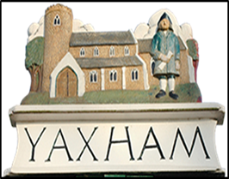
YAXHAM PARISH COUNCIL
Pinebanks, Station Road, Yaxham, Norfolk NR19 1RB
Tel: 01362 690290 yaxhamparishclerk@gmail.com

15th September 2018
Dear Clint Green Resident,

Consultation – WW1 Centenary 11.11.2018 – Commemorative Bench for Clint Green

My apologies for another consultation, but the Council would really like your views. The Council has agreed to a WW1 Commemorative Bench in Yaxham, on the Recreation Field by the Village Hall, and propose to do the same for Clint Green, if residents would like one and if a suitable site could be identified, and the landowner agrees. The bench looks like this:
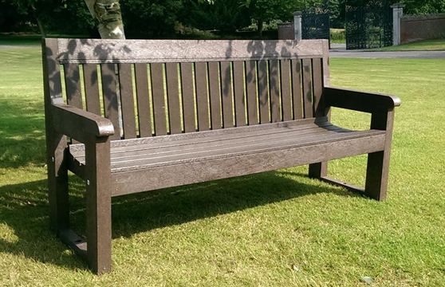
The bench will carry a memorial inscription on the top plank referencing the WW1 Armistice Centenary on 11.11.2018.

Can you therefore please complete the consultation form below and return it to the Parish Council by: putting it in the “post” box at the School, posting it to the address above, or emailing it to yaxhamparishclerk@gmail.com, by 4pm 21st September 2018. Thank you.

Peter Lowings,
Chairman
-------------------------------------------------------------------------------------------------------------------------
I live in or around Clint Green and my Post Code is NR19 1…

- I agree with placing a Commemorative Bench in Clint Green |  | YES / NO
- I would like to see it placed at

If you do have a piece of land open where a bench could be sited, please send us the details and how we can contact you to discuss.
PS This form is also available at www.yaxham.com

